Real Analysis: MAT 221

LIMIT & CONTINUITY

PROBLEMS:

Part A. Find the limit of the following functions:
- 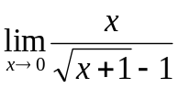 12. 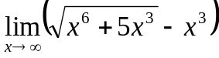
- 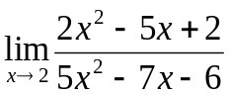 13. 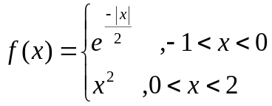
- 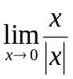 Find 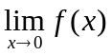
- 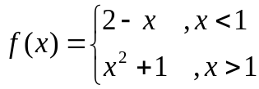 find 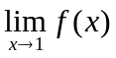 14. 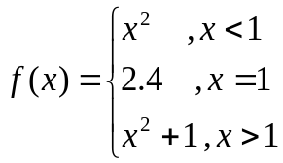
- 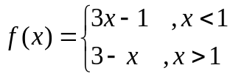 find Does exist ?
- 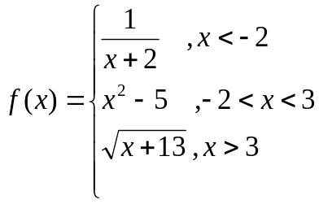 find 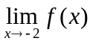 and 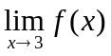
- 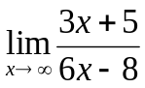 15. 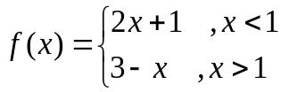
- 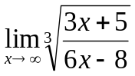 find
- 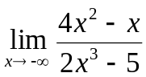 16. Prove that 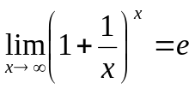
- 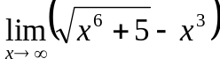
- 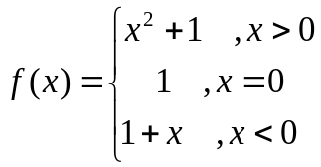 find
You are responsible to study problems from reference books as well to improve your knowledge.

Part B. Test the continuity of the following functions:

- 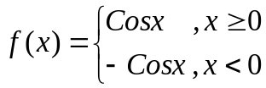 at x = 0
- 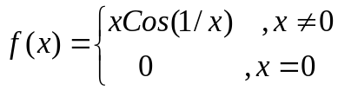 at x = 0
- 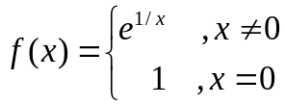 at x = 0
- 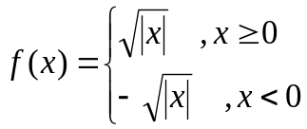 at x = 0
- 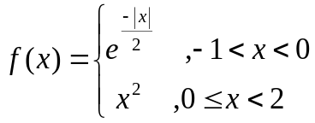 at x = 0
- 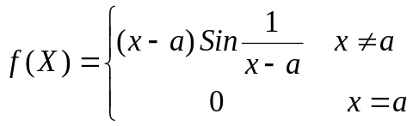 at x = a
- 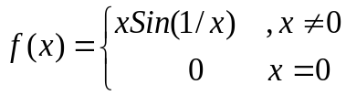 at x = 0
- 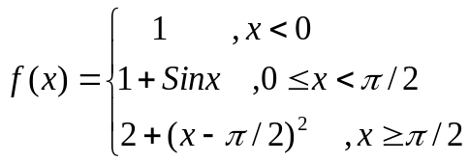 at x = 0 and 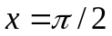
- 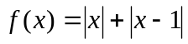 at x = 0 and x = 1

- 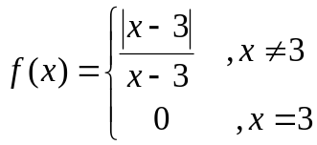 at x = 3

- 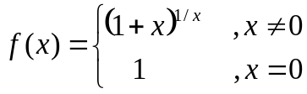 at x = 0

- 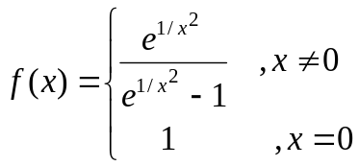 at x = 0

Part C. Indeterminate form

Evaluate:
1. 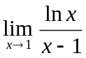 2. 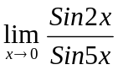 3. 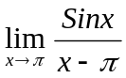 4. 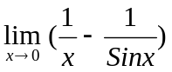

5. 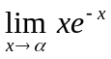 6. 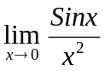 7. 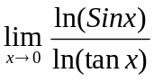 8. 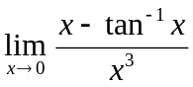
9. 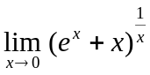 s 10. 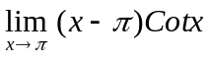 11. 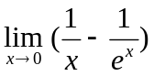
12. 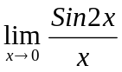 13. 

